**Program Deleverables**

**D2B**

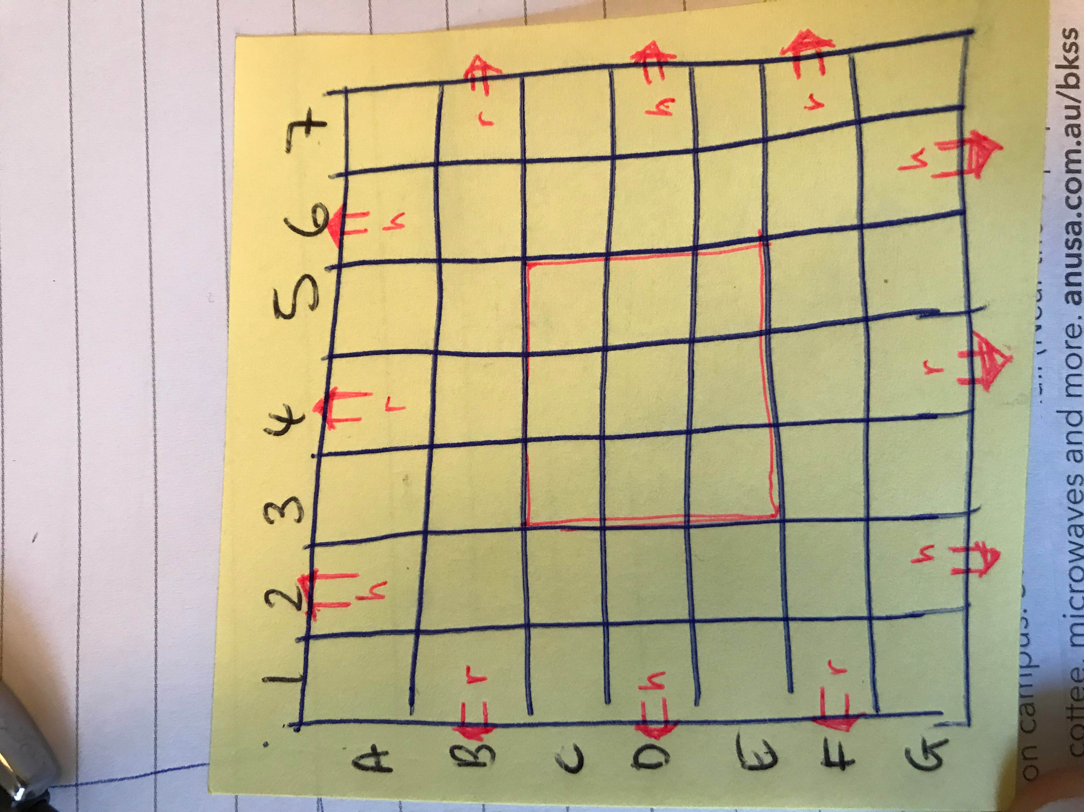

**The Whole Process**

**Logical aspects & version aspects**

1、Generate a board with 7*7 blank tiles

2、for each round, generate random dices, this method already has in RailroadInk. # task 7

3、then make a legal move given each tiles，#task10, during this process, we may need to check whether a given boardstring is valid or not # task 6, in this process, we then need

(1) whether the neighboring tiles are connected # task5

(2) whether a board string is well formed #task4…

After we make each move, we add movement to boardstring.

(Thus the boardstring is built up from nothing)

And at the same time, we **need to make change on the board.**

4、make four legal moves by iterating step3 four times. And calculate the current score # task 8

5、iterate 3 and 4 for 7 times. Calulate the final score # task12

**Classes/Enum**

1、TilesGenerator

For each turn, randomly generate 3 A tiles and 1 B tile. It is a simulation to dices.

Has function DiceGenerator.gettiles() and return an array like

[A2, A5, A4, B1] **Idea denied, because a similar function already in RailroadInk.**

**1、 Board class**

**2、TilesDescription Enum**

Create a TilesDescription Enum, in the enum each instance has an name representing the Tile number and orientation, like A07(means tile A0, orientation7) ,B16(means tile B1, orientation 6) ,S13…, and each instance has five field: up, down, left and right and centre to describe what is in these directions, like highway, railway, blank or station.

**D2C**

Before week6, finish part one, group tasks, but can have contribution statement

When we think about task6, (which is the most core part if the whole design I think), we first try to split the boardString into TilePlacementString, then we check whether each TilePlacementString is legal based on its former tilePlacementString.

To realize this, we check (1) whether a tile is neighboring exit, and if true, whether the connection is legal. If both are true, then the placement is legal, or

(2) check its previous TilePlacementString, find the tiles that neighboring to it, and check if the neighboring is legal. If true, the placement is legal, or if none of the above checks are legal, then the placement is illegal.

-GUI of the game

**public class Viewer extends Application{**

**}**

-Core of the game

- Has properties of all the pieces in original orientation.

**public enum Piece**{

-Piece constructor (gives each piece its property)

-getProperties method (and returns properties of piece in a string array)

}

- Represents a single Tile on the board with its properties ( Consists of Piece, Spot, and Orientation)

public class Tile{

String tileplacement;

-getSpot method (returns the coordinates for the Tile give five character tilePlacementString)

-rotateTile method (changes property of Tile when rotated to certain orientation, return the new properties in a string array)

- isValidExit method(if a tils is neighboring at exit, check if the connection is valid, for example “A3B02” is false and “A1F01” is true.

-isCentre method (check whether a tile is within centre of board)

-Tile constructor (gives Tile its TilePlacementStirng, like”A3B24”)

This.tilepalcementstring =

*-toString method (To get placement string of the tile) ?*

}

- Creates Coordinates on the Board and gives properites to Exits

public class Spot{

-Spot constructor (gives spots its coordinate and property)

-isExit method(Checks if a tile is neighboring at exit, for example, “A3B02” is true, “A1F01” is true, and “B0C23” is false )

-isNeighboring method(check whether two spots are neighboring)

-NeighborSide method(input two neighboring coordinate, return which side they are neighboring, like “downside, upside” means the first tile’s downside is neighboring with second tile’s downside)

-isOccupied (Checks if the spot is occupied by a Tile)

isCentre method

*-toString method (gets the String of the spot coordinates)*

}